**Project Design Phase-II**

**Data Flow Diagram & User Stories**

|  |  |
| --- | --- |
| Date | 16 October 2022 |
| Team ID | PNT2022TMID35929 |
| Project Name | Real-time river water quality monitoring and control system |
| Maximum Marks | 4 Marks |

**Data Flow Diagrams:**

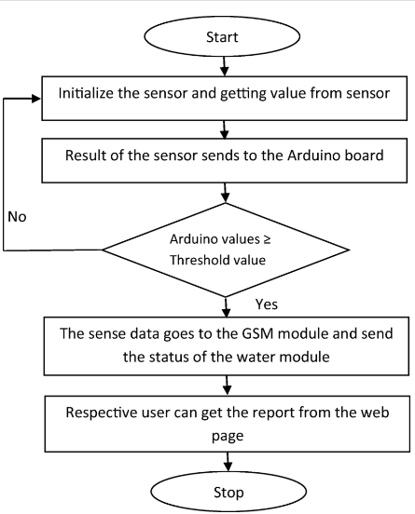

**User Stories**

| **User Type** | **Functional Requirement (Epic)** | **User Story Number** | **User Story / Task** | **Acceptance criteria** | **Priority** | **Release** |
| --- | --- | --- | --- | --- | --- | --- |
| Customer (Mobile user) / (web user) | Registration | USN-1 | As a user, I can register for the application/website by entering my email, password, and confirming my password. | I can access my account / dashboard through email | High | Sprint-1 |
|  |  | USN-2 | As a user, I will receive confirmation email once I have registered for the application/website | I can receive confirmation email & click confirm | High | Sprint-1 |
|  |  | USN-3 | As a user, I can register for the application through Facebook | I can register & access the dashboard with Facebook Login | Low | Sprint-2 |
|  |  | USN-4 | As a user, I can register for the application/website through Gmail | I can access my account / dashboard through Gmail | Medium | Sprint-1 |
|  | Login | USN-5 | As a user, I can log into the application/website by entering email & password | I can access the application/website | High | Sprint-1 |
|  | Dashboard | USN-6 | As a user, I can access various types of river water samples | I can view the contents of dashboard | Medium | Sprint-1 |
|  | View information | USN-7 | As a user, I can view the quality parameters of water samples such as pH, temperature, turbidity etc. | I can view the information in the application/website | High | Sprint-2 |
|  | Logout | USN-8 | As a user, I can logout from my account | I can logout from the account | Medium | Sprint-2 |
| Customer Care Executive | Feedback | USN-9 | As a customer care executive, I can receive the feedback from the user | I can look through the feedbacks | High | Sprint-3 |
|  | Respond | USN-10 | As a customer care executive, I can respond to customer queries | I can answer to the customer call and respond to their feedbacks | High | Sprint-3 |
|  | Communicate | USN-11 | As a customer care executive, I can communicate the user queries to the administrator | I can share the views of user toward the website to the administrator | High | Sprint-3 |
| Administrator | Update | USN-12 | As an administrator, I can update the information | I can update the changes in the information whenever required | High | Sprint-4 |
|  | Troubleshoot | USN-13 | As an administrator, I can analyse and solve serious problems in the application/website, if any | I can fix the errors in application/ website | High | Sprint-4 |
|  | Backup | USN-14 | As an administrator, I can create backup from the information | I can recover the lost information by having backups | High | Sprint-4 |